WEST NORFOLK PONY CLUB & RIDING FOR THE DISABLED
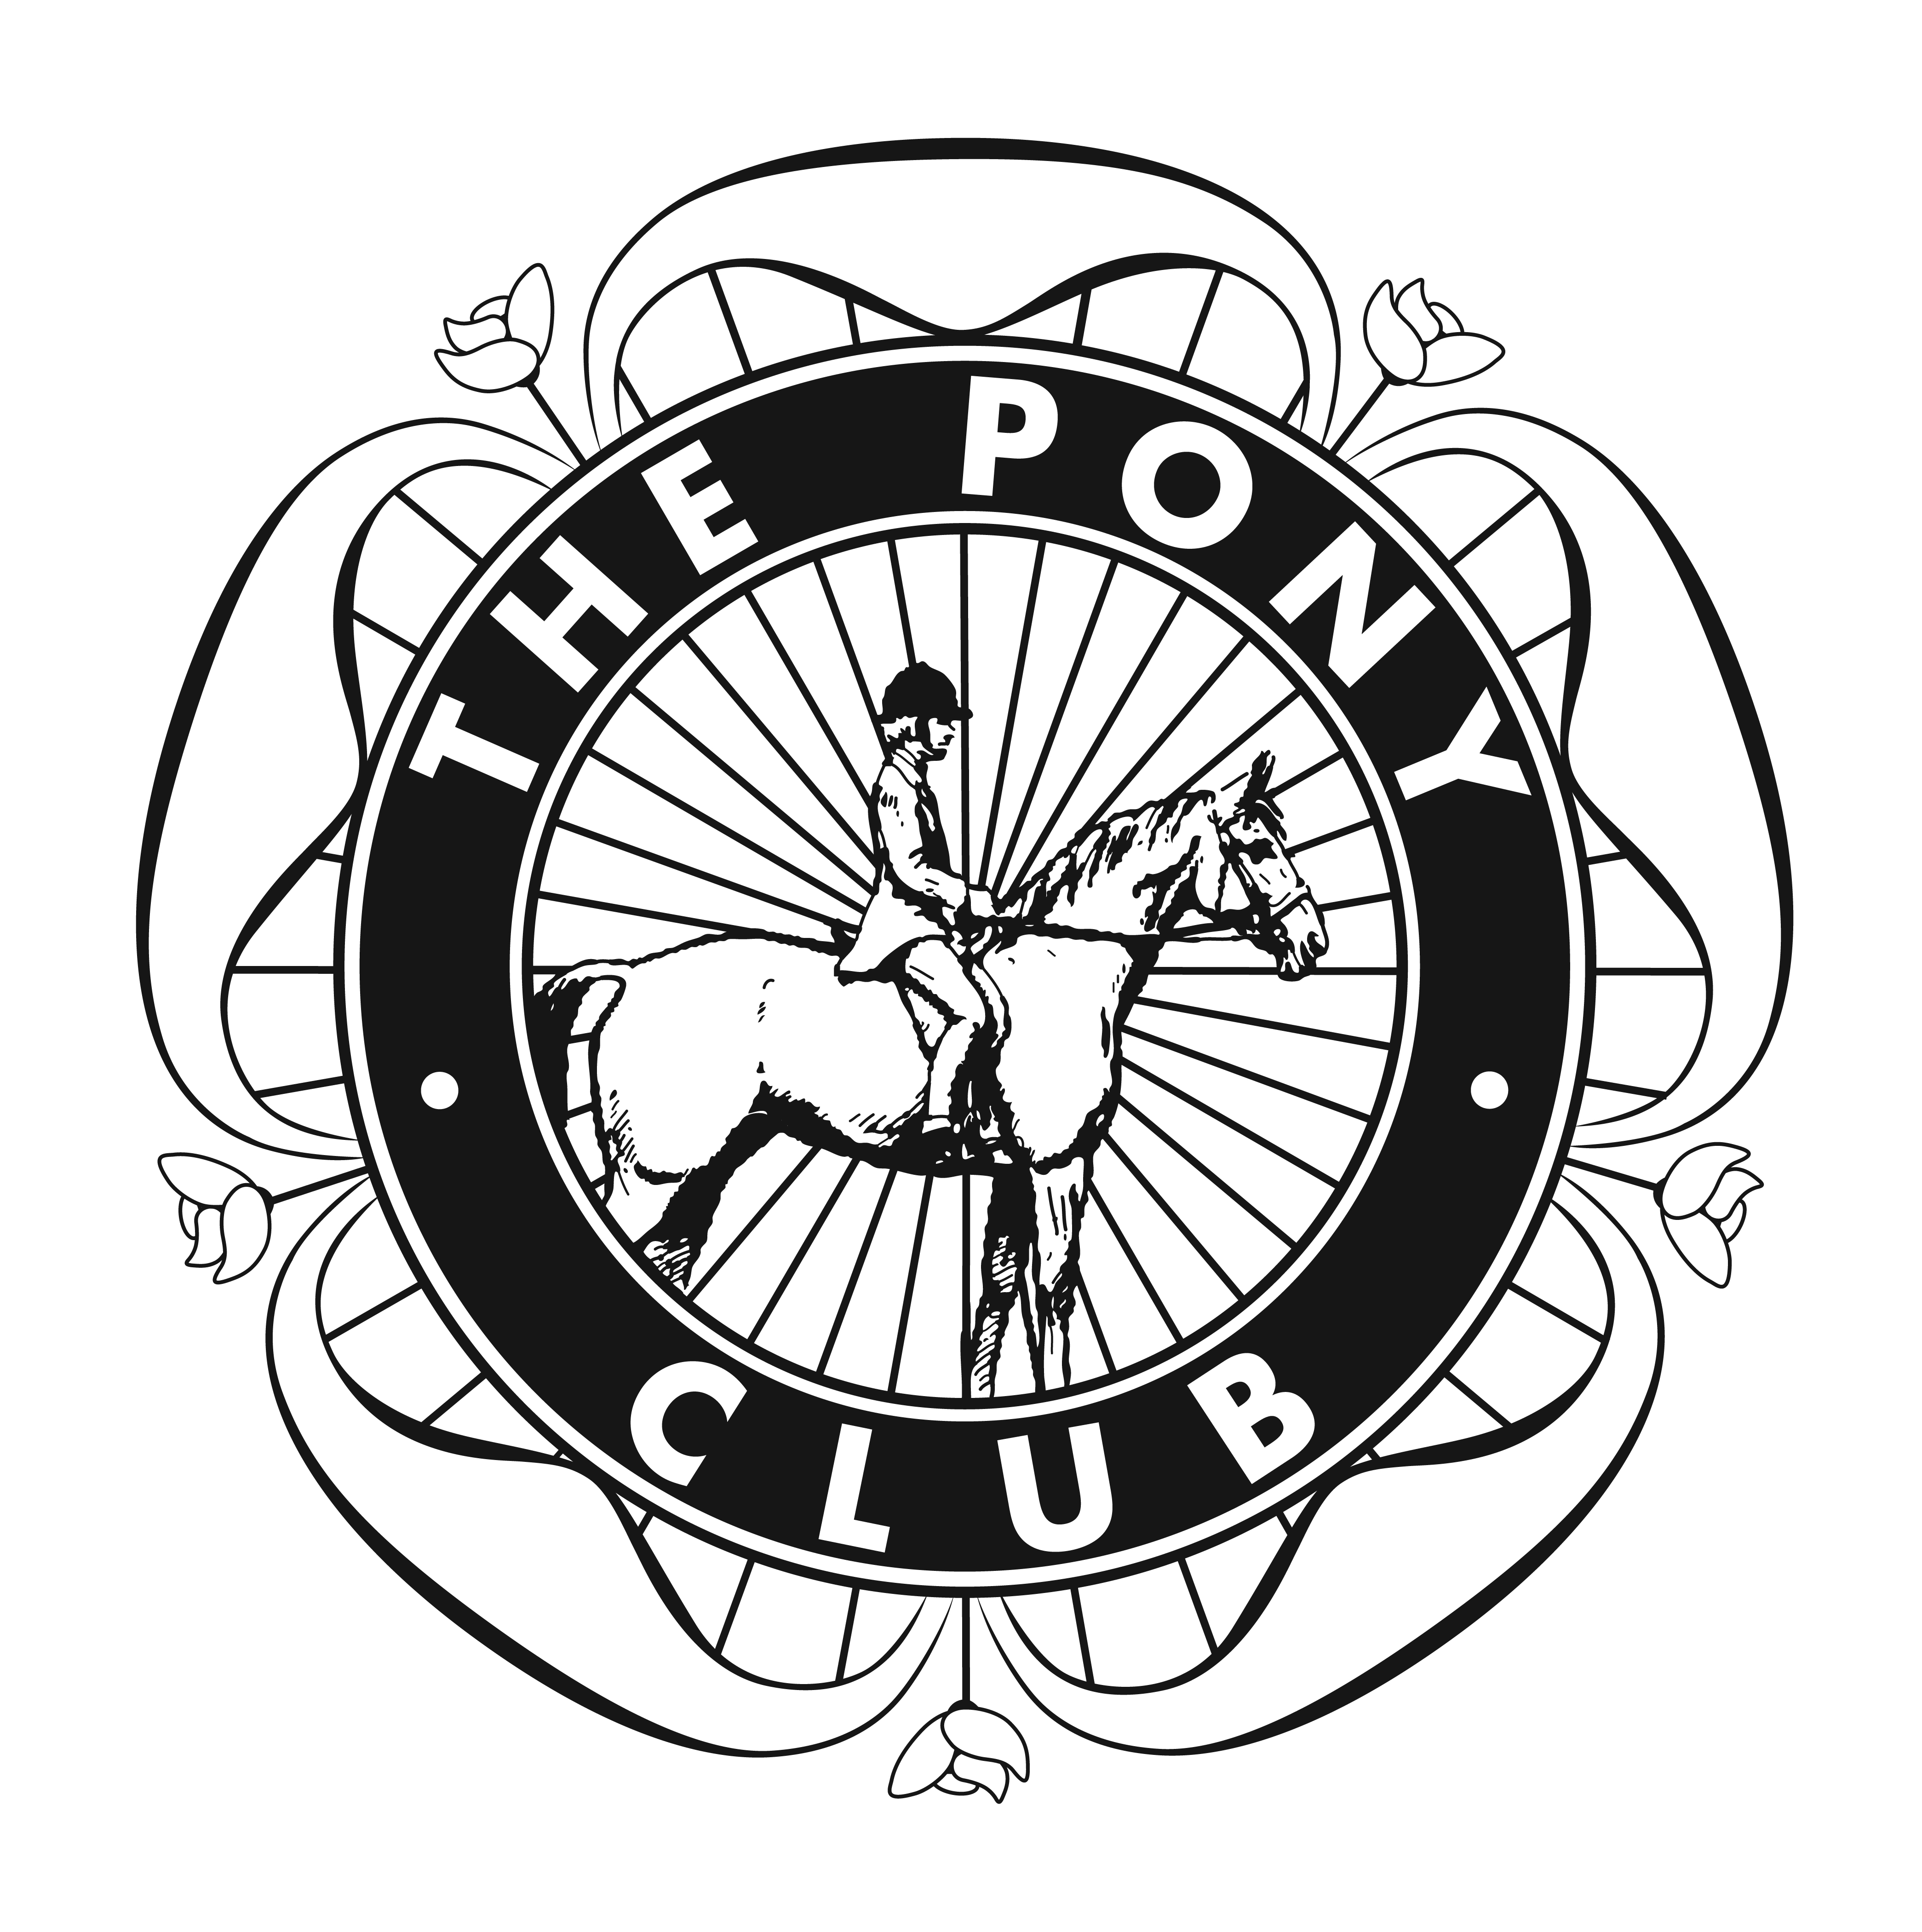
WINTER DRESSAGE LEAGUE 2021/22
THE MAGPIE CENTRE, WALLINGTON HALL,
RUNCTON HOLME, KINGS LYNN, PE33 0EP
BY KIND PERMISSION OF MR & MRS J.PLAXTON
 | 24th OCT  2021 | 21st NOV  2021 | 12th DEC  2021  TINSEL ENCOURAGED | 23rd JAN  2022 | 13th FEB  2022
CLASS 1 | RDA  (RDA riders only) | RDA  (RDA riders only) | RDA  (RDA riders only) | RDA  (RDA riders only) | RDA  (RDA riders only)
CLASS 2  CLASS 3  10 yrs &  under  CLASS 4 | PC Walk Trot  Dressage 2013  (PC only- 10yrs  and under)  PC Grassroots  Dressage 2018  PC Grassroots  Dressage 2018 | PC Introductory  Dressage 2019  (PC only- 10yrs  and under)  PC Grassroots  Dressage 2018  PC Grassroots  Dressage 2018 | PC Walk Trot  Dressage 2013  (PC only- 10yrs  and under)  Christmas Fancy Dress  PC Grassroots  Dressage 2018  PC Grassroots  Dressage 2018 | PC Introductory  Dressage 2019  (PC only- 10yrs  and under)  PC Grassroots  Dressage 2018  PC Grassroots  Dressage 2018 | PC Walk Trot  Dressage 2013  (PC only- 10yrs  and under)  PC Grassroots  Dressage 2018  PC Grassroots  Dressage 2018
CLASS 5 | PC Novice  Dressage 2020  (PC only) | PC 90  Eventing 2013  (PC only) | a)PC Novice WQ  Dressage 2020  b)PC Intermediate  Dressage 2013 | PC 90  Eventing 2013  (PC only) | a)PC Novice WQ  Dressage 2020  b)PC Intermediate  Dressage 2013
CLASS 6 | BD Intro A 2008 | BD Intro B 2009 | BD Intro C 2016 | BD Intro A 2008 | BD Intro C 2016
CLASS 7 | Prelim 1 2006 | Prelim 2 2016 | Prelim 7 2002 | Prelim 1 2006 | Prelim 18 2002
CLASS 8 | Prelim 12 2005 | Prelim 13 2006 | Prelim 14 2006 | Prelim 18 2002 | Prelim 12 2005
CLASS 9 | Novice 27 2007 | Novice 24 2010 | Novice 28 2008 | Novice 30 2006 | Novice 34 2009
CLASS10 | Novice 28 2008 or  Elem 42 2008 or  PC Intermediate  Dressage 2013 | Novice 30 2006 or  Elem 44 2002 or  PC Open Dressage  2020 | Novice 34 2009 or  Elem 49 2009 or  PC Open Dressage  2020 WQ | Novice 24 2010 or  Elem 50 2007 or  PC 100  Eventing 2015 | Novice 27 2007 or  Elem 49 2009 or  PC Open Dressage  2020 WQ

WQ - Barrier Animal Health Winter Qualifier (PC only)
EQUINE INFLUENZA VACCINATIONS – all horses/ponies must have received a minimum of 2 primary vaccinations. Subsequent boosters must have been given within the last 12 MONTHS and not within 6 days of the show. ALL PASSPORTS to be brought to secretary for checking PRIOR TO UNLOADING.
ENTRIES and PAYMENT - online via West Norfolk Hunt Pony Club website or Cheque to WNHPC to Miss J Young, The Watermill, West Newton, Kings Lynn, PE31 6BA Tel: 01485 600294/07946420423
PC members and RDA- £12 per class: Winter Qualifier- £14 per class: Others- £14 per class:
Rules and Conditions of Entry
Competition Date……………………………………..
Rider | Horse | Pony Club (Y/N) | Class- Specify test | Fee
 |  |  |  | Total:
Contact Tel…………………………………… Contact Email……………………………………………………………….

Note extra rules for Barrier Animal Health Winter Qualifiers

- To be run under Pony Club rules for dressage 2020 for PC tests and BD rules for other classes.
- Entries to be received Monday before competition. Late entries only if places available at £2 extra charge.
- Rosettes to 6th place and rosette to highest placed PC member in each class. Points will be awarded to 6th place plus 1 extra point for competing. Trophies to winner in class 1, 2 & 3 Combined, 4 & 5 combined, 6, 7 & 8 combined, 9 & 10 combined, to be awarded at end of Winter League. Combination of horse and rider must attend 3 shows to qualify.

- Please respect Wallington Hall- NO DOGS, NO MUCK TO BE LEFT ON FIELDS
- Times- on Friday before competition on WNHPC website.
- Neither the Organisers nor the persons acting on behalf accept liability for any loss, damage, accident, injury or illness to competitors, spectators or any person or property whatsoever. The Organisers of this event have taken reasonable precautions to insure the health and safety of everyone present. For these measures to be effective everyone must take all reasonable precautions to avoid and prevent accidents occurring and must obey the instructions of the Organisers and all the Officials and Stewards.
- The Organisers reserve the right to cancel or alter any class. Classes may run in a different order to that stated on schedule. Please follow stewards instructions re any Covid restrictions that may be implemented.
- Proceeds to be split evenly between West Norfolk Hunt Pony Club and West Norfolk Riding for the Disabled.

We are very grateful to all our sponsors:

- Barrier Animal Health
- GJL Animal Feeds Ltd Tel 01328 851 351
- Nags Essentials – www.nagsessentials.co.uk Tel 01760 444 281

- West Norfolk Rugwash Tel 07746 011 598
- West Norfolk Farriery Ltd Tel 07795 632877

